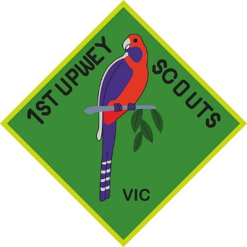

1st Upwey Scouts

6 Mahony Street  
Upwey VIC 3158

[mikelynpwr@gmail.com](mailto:mikelynpwr@gmail.com) or [star_9th@hotmail.com](mailto:star_9th@hotmail.com)

Dear

**Re: Donation of good to support fundraising silent auction**

I am writing to you as a member of the 1st Upwey Scouts Jamboree Fundraising Committee to request your help. The Australian Scout Jamboree is a national event for Scouts that is run every 3 years. It is a 10-day camping experience that involves a wide range of activities, challenges, and events designed to promote personal growth, community involvement, and leadership skills in children aged 11-14 years of age. Scouts typically get one opportunity to attend Jamboree during their Scouting membership. The upcoming Australian Scout Jamboree is happening between 6th and 15th of January 2025 in Maryborough, Queensland. For more information regarding the Jamboree there is an assigned website at <https://aj2025.com.au>.

With the cost of transport and cost of living increases this Jamboree is proving to be financially prohibitive for many families (especially where they have 2 eligible children). The cost per child for Victorian Children is $3000 to attend this Jamboree.

As a result, I am writing to ask if you are able to assist with donating goods to support a silent auction or raffle at our trivia night planned for 3rd August 2024. The theme of our trivia night is ‘The Great Outdoors’ and we plan to auction off hampers under the following themes:

1. Outdoor 2. Farmers Foodie Market 3. Pamper 4. Entertainment 5. Gardening
2. Family Fun 7. Chocolate 8. Wine

We also need prizes for the ‘gold coin’ games we will run on the night.

We also need decorations to support our theme including table cloths and decorations that depict a deserted island, sky, city scape and forest (we plan to set these up a selfie corners).

If you are able to assist in any way we would love for you to make contact with either Lynda Power; 0433 816 951 or Sally Waterman; 0421323400 (1st Upwey Scouts Fundraising Committee).

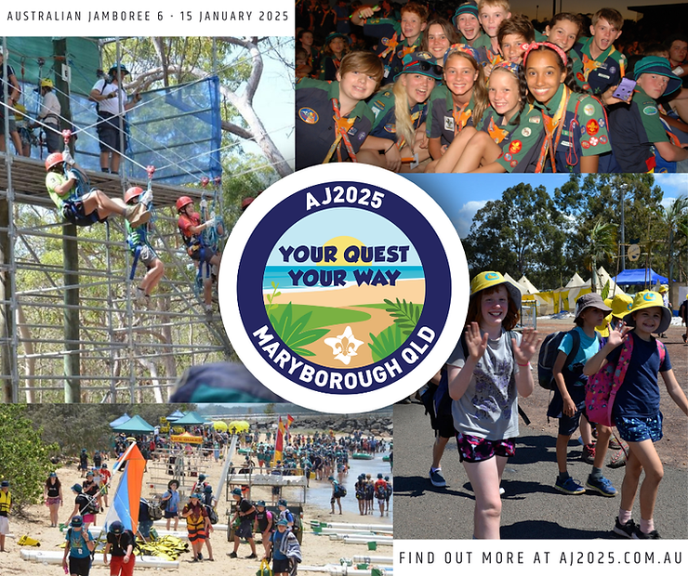

Thank-you so much for considering our request.

Yours in Scouting,

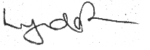

Lynda Power and 1st Upwey Scouts

Fundraising Committee